***Project Report***

***Executive Summary:***

Power Generation in the US has been majorly ruled by “coal” for several decades because of its high-burning nature that leads to more power units being generated. Unlikely, natural gases have changed this hereditary through the energy revolution that created additional opportunities for technologies and systems with superior performance and reduced costs. “Natural Gases” are likely to overthrow coal in the future because it is currently available at cheaper prices with the value-added benefits of protecting the environment.

***Recommendations:***

“The world is heating up”, if we want to save our world, we need to stop polluting the environment. Power Generation is a major contributor to pollution in the world, so to avoid this we need to use fuels such as natural gases, bio-gases and solar power which emits less pollution.

***Problem Statements***

* What are the major types of fuels used in power generation in the USA?
* What kind of impurities is emitted into the atmosphere through this power generation process?
* Are these emissions within the permissible limits?
* What is the average cost induced in generating power in the US?
* How many units of fuel are being consumed to generate power in the US?

***Select the best segmentation and how would your segmentation help understand power generation in the US?***

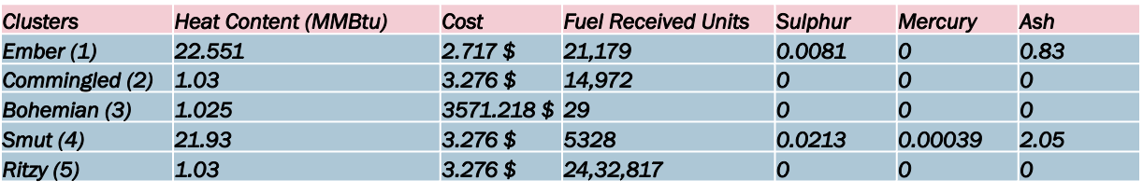

Ans. The best segmentation which could help better understand the power generation in the US is the one which generates more of the power units when compared to the others. Ideally, we would want to see which of the power sources generates more amount of power units in metric million british thermal units with moderate cost and fuel units being received.

***“Ember Cluster”*** is the best segmentation which can be chosen to better understand the power generation in the US, the amount of heat generated i.e. the amount of power units thus generated is quite high when compared to the other clusters.

* The fuel source thus used to generate power is **Coal**.
* The fuel units received to generate power in this cluster are **21,179 Units**.
* On average **22.551 Million Metric British Thermal Units** of power are generated for an intermediary cost of **2.717$**.

***Facts about power generation in the US towards greenhouse gases:***

There are about 1,400 coal and oil-fired electric generating units (EGUs) at 600 power plants in the USA. They emit harmful pollutants, including sulphur, mercury, non-mercury metallic toxins, acid gases, and organic air toxins such as dioxin.[4]

Power plants are currently the dominant emitters of sulphur (50 per cent), acid gases (over 75 per cent) and many toxic metals (20-60 per cent) in the United States.[4]

Most importantly it should be noticed that we are living in a global crisis era where the earth is getting warmer day by day due to the increase of pollutants in the atmosphere. Power Generation often leads to an increase in pollution.

The best segmentation now after adding another factor i.e. ***nature friendly*** will be shifted from ***“Ember Cluster”*** to ***“Commingled Cluster”***. Although the fuel type natural gases didn’t result in excess power units being generated, if we want to abide by something that is going to protect our nature then we need to shift the fuel type used in power generation from coal to natural gases.

***Fuel Generation Using Natural Gas***

Here, in our analysis we have a cluster i.e. ***“Commingled Cluster”*** where the fuel source used to generate power is Natural Gas or Oil, we get to see a few things here, but the most important thing which we observed is that the heat units generated by burning the fuel are quite less i.e. burning over 13000 units of natural gas generates 1.030 MMBtu of heat which is further costing 3.276$.

Although the fuel units received were moderate in the above cluster, the heat generated is very less which eventually is leading to less generation of power.

So, to understand why is the cluster with Natural Gas or Oil as the fuel source not considered the best cluster, we need to understand the following point,

* In terms of generating power units, **coal** is considered the best source, because coal burns hotter than **oil or gas** which means we get more BTUs per pound than from most other fuels.

***Facts:***

The future is all about uncertainties and the trend which is observed at present might not be the same in the future.

In the United States coal has been a major source for generating power for decades, but due to some factors, we are seeing a churn in the fuel source being used for power generation in the US.

* Increase in Dollar Rate,
* Greenhouse Gases Emission Regulation,
* Cheaper Natural Gas

As per ***CNBC***, “In the US fuel source used to generate power in 2010 was Coal - 44% and Natural Gas - 21% and presently it is Coal at 30% and Natural Gas at 31%. [6]

This decline in the fuel source is expected to continue and there will be a day when the sole source used to generate power would be Natural Gas alone, “***CNBC Expert Discussion Panel”***.

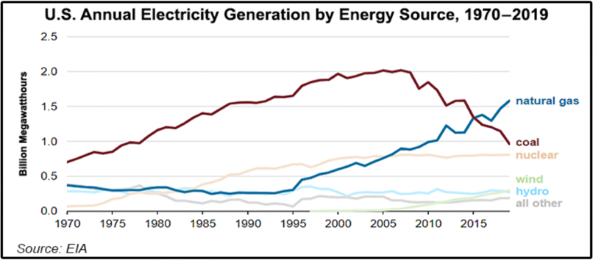

***Discussion – (Future Power Generation in the United States – CNBC) [6]***

* There is a possibility that the usage of high amounts of fuel units of natural gas will lead to excess power generation when compared to that of coal as a fuel source.
* The availability of Natural Gas at a cheaper price can be one main driving factor for the use of natural gases in more quantity to generate power in the US in the future.

***Findings***

* Major fuel sources used to generate power in the US are Gas and Coal with very less amount of Oil.
* Coal has the longest combustion when compared to other fuels, that’s the sole reason for the clusters having coal as a fuel to produce more heat resulting in more power.
* Natural Gas has very less combustion, the moment it’s introduced to the air upon its ignition it’s going to get off instantly, this is why natural gas as a fuel to produce power is having less heat resulting in less power being generated.
* In terms of generating more power units, coal can be considered the best source of fuel when compared with other sources such as gas and oil because of its high heat emissions at an intermediary price with medial units of fuel being received (Ember Cluster).
* But when it comes to selecting a fuel source which has fewer impurities being emitted to the environment, the ideal fuel source to consider would be Natural Gas. (Commingled Cluster).

***Conclusion –***

“All in All, we could call out that power generation in the US is diversified broadly, the use of different fuel types leads to varied units of power units being generated with added cost as well as impurities polluting the environment, the use of a specific type of fuel based on the requirements is the key.

Coal seems to generate more power units at the cost of polluting the environment whereas Natural Gases seem to generate fewer power units with fewer pollutants being released into the atmosphere. If the primary objective is to maximize power generation by generating more power units, then “Coal” can be deployed as the primary source of fuel, whilst if the objective is to abide by the “Greenhouse Gases Emission Regulation” where the goal is to control the level of pollutants which are being released into the atmosphere then we could go with “Natural Gases” as the primary source of fuel.”

***Appendix:***

1. <https://www.eia.gov/tools/faqs/faq.php?id=107&t=3>
2. <https://www.investopedia.com/terms/s/sourcrude.asp>
3. <https://www.eia.gov/todayinenergy/detail.php?id=29812>
4. <https://www.epa.gov/mats/cleaner-power-plants>
5. <https://www.google.com/url?sa=i&url=https%3A%2F%2Fenergyeducation.ca%2Fencyclopedia%2FNatural_gas_power_plant&psig=AOvVaw1dGcLgkwjd_Q_U5VeJzR3B&ust=1670518859218000&source=images&cd=vfe&ved=0CA4QjRxqFwoTCMC6-Or95_sCFQAAAAAdAAAAABAE>
6. <https://www.cnbc.com/2015/07/14/natural-gas-tops-coal-as-top-source-of-electric-power-generation-in-us.html>
7. <https://www.tva.com/energy/our-power-system/coal/how-a-coal-plant-works#:~:text=Coal%2Dfired%20plants%20produce%20electricity,to%20start%20the%20process%20over>
8. <https://www.naturalgasintel.com/u-s-coal-fired-power-at-lowest-levels-in-42-years-as-natural-gas-reaches-new-records/>

***Note:***

***None of the additional references and points has been stated to deviate from the study they were solely added to stand as supporting statements to the analysis done and to that to the findings as well.***